1. Go to the Microsoft Store and Search for “Intune Company Portal”  
    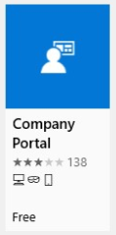

Wireless Setup Video if needed

<https://www.youtube.com/watch?v=RLs91CRMX54&>

**Mitchell Tech Wireless and Printing Setup**

1. Select and install it, sign in with a Microsoft account if needed.
2. Launch the app and sign in with your Mitchell Tech e-mail address and password. 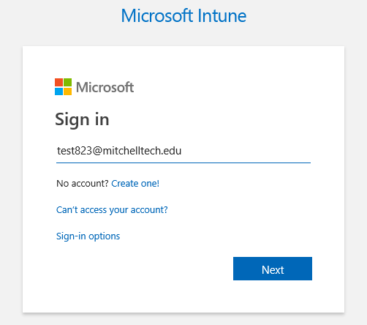
3. Select “This App Only”  
   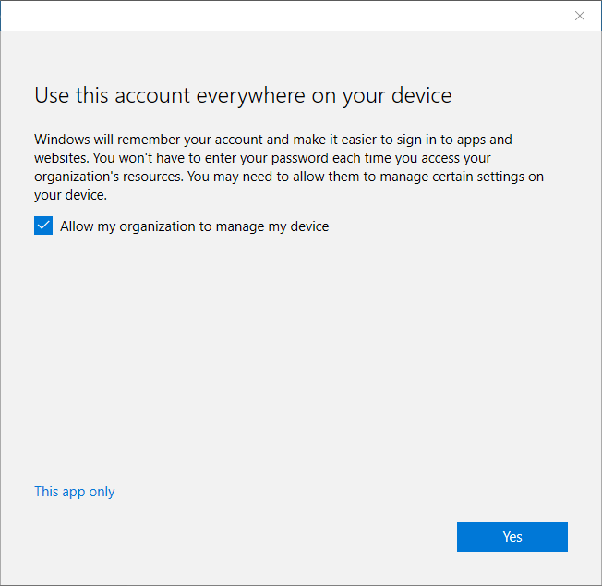
4. Select “This device hasn’t been set up for corporate use yet. Select this message to begin setup.” 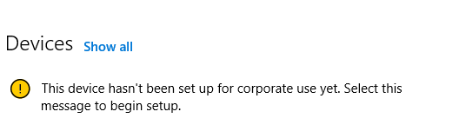
5. Select “Next” on Set up your device
6. Select “Add work account”
7. Enter your MTC e-mail address if it isn’t populated and then your MTC password
8. Let the next step finish, shown below. This step may take a few minutes depending on the speed of the internet and your laptop.  
   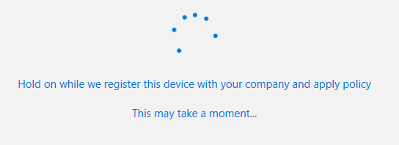
9. Select “Next” on Add work account to this device
10. Select “Done”
11. The final steps happen silently and may take up to 10 minutes depending on the speed of your internet. To verify its complete go to Settings, search for Wi-Fi settings, then select Manage known networks and MTC-Secure should be added, like the example shown below. 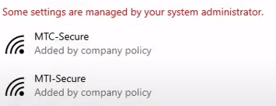

**Setting up printing for on campus**

1. Go to <https://mytech.mitchelltech.edu/ICS/HELP_Desk/>
2. Scroll down to Printing Software, click on the link and run the file that is downloaded and “Yes” on any prompts.
3. “OK” on the SafeQ6-MU45 Prompt. The install process goes on its own. Once complete the black command box will disappear on its own.
4. After the box disappears, everything can be closed. Setup is complete.   
    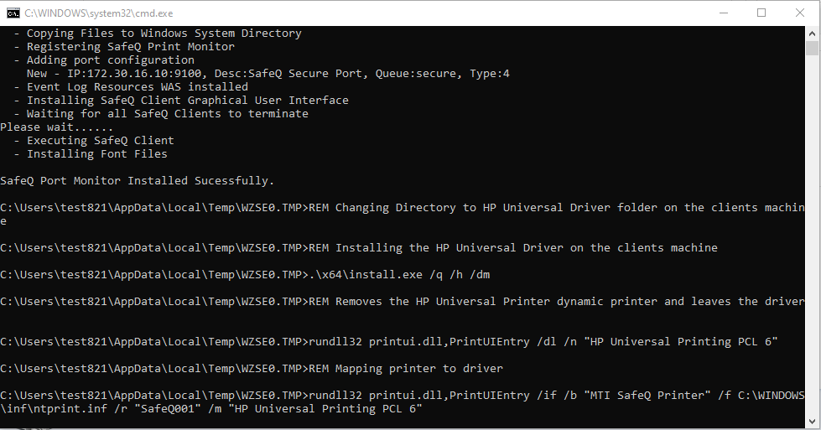

Printing setup video on MyTech and the Technology Tab on the right side.